Exploratory Data Analysis Report
Mobility Predictors: Identifying Structural Conditions
for Upward Economic Mobility
Jeff Charles
DSE6311: Capstone
Merrimack College
March 2026

Background and Research Question
This report is addressed to the Urban Institute and the National Low Income Housing Coalition (NLIHC) as primary stakeholders. Its purpose is to present exploratory findings from the 2011 wave of the Panel Study of Income Dynamics (PSID) for households that began in the bottom 40 percent of the national income distribution, and to characterize the structural conditions those households faced at baseline. The analytic sample of 2,375 households was constructed by panel-linking the 2011 and 2021 PSID family files through the PSID Cross-Year Individual file, enabling construction of the full baseline-to-outcome dataset needed for the subsequent modeling phase.
Research Question
Among households in the bottom 40 percent of the U.S. income distribution in 2010, which combination of structural baseline conditions - including wealth, housing cost burden, family structure, educational attainment, employment status, geography, and demographic characteristics - best predicts whether a household crosses the national median income threshold by 2021?
Hypothesis and Predictions
The central hypothesis guiding this project is that structural wealth and housing cost burden at baseline are stronger predictors of upward income mobility than educational attainment alone, and that their predictive power compounds across demographic groups. This hypothesis is grounded in Chetty et al.’s (2014) finding that neighborhood-level structural conditions outperform individual characteristics in predicting long-run income outcomes, and in evidence that parental wealth buffers households against income shocks in ways that earned income alone cannot (Desmond, 2016).
Specifically, we predict that: (1) household net worth at baseline will rank among the top three most important features in both Random Forest and XGBoost models, outperforming educational attainment; (2) housing cost burden will be negatively associated with mobility outcomes and carry stronger predictive power than geographic region alone; (3) K-Means clustering will identify a distinct high-burden, low-asset household profile with substantially lower mobility rates; and (4) educational attainment will retain predictive value but will be conditional on baseline wealth, reflecting findings that credentials amplify existing structural advantage rather than substituting for it (Putnam, 2015). The preliminary EDA results presented below offer early evidence relevant to each of these predictions.
Methods
Dataset and Acquisition
The primary dataset for this analysis is the Panel Study of Income Dynamics (PSID), maintained by the Institute for Social Research at the University of Michigan (University of Michigan Institute for Social Research, 2023). The PSID is the longest-running longitudinal household survey in the United States, originally launched in 1968 with a nationally representative sample of approximately 5,000 households. The survey collects data biennially (since 1997) on income, wealth, employment, housing, demographics, and family structure. Data for this project were obtained as fixed-width ASCII text files from the PSID public-use data portal at psidonline.isr.umich.edu, which requires free researcher registration. The 2011 Family File (FAM2011ER), the 2021 Family File (FAM2021ER), and the Cross-Year Individual File (IND2023ER) were downloaded along with their accompanying Stata (.do) setup files and codebooks. No API or web scraping was used; data were accessed through direct download from the PSID distribution system.
The 2011 wave is the baseline for this study because it aligns with a PSID wealth supplement wave, making household net worth data directly available alongside all other structural predictors within a single integrated survey year. The 2021 wave provides the follow-up income outcome, and the Cross-Year Individual File provides the person-level panel identifiers needed to track the same household head from the 2011 wave to the 2021 wave. The full 2011 family file contains 8,907 household family units; the 2021 family file contains 9,207; and the Cross-Year Individual file contains 85,536 individual records spanning 1968 to 2023.
Data Cleaning and Panel Linkage

Variable extraction was performed using Python by parsing the column-position specifications in the Stata .do setup files. The panel linkage proceeded in three steps. First, the Cross-Year Individual file was used to identify individuals who served as household head (sequence number = 1) in the 2011 wave and who had a valid 2021 interview number, yielding 5,998 linked head-level records. Second, this linkage file was merged with the 2011 Family File on the 2011 interview number and with the 2021 Family File on the 2021 interview number, producing a panel-linked dataset of 5,998 households observed at both time points. Third, the sample was restricted to households in the bottom 40 percent of the 2010 income distribution (at or below the 40th percentile threshold of $37,190), yielding the final analytic sample of 2,375 households.
Several variables required recoding from numeric PSID codes to interpretable categories. Educational attainment was grouped into five ordered categories: Less than High School, High School Diploma, Some College or Associate's Degree, Bachelor's Degree, and Graduate Degree. Employment status was consolidated from eight original codes into five categories. Race and ethnicity were combined from separate race and Hispanic origin variables into four categories, with Hispanic origin taking precedence. Geographic region was mapped from PSID Census region codes to four standard U.S. regions. Housing cost burden was computed as the ratio of annualized monthly housing expenditure to total family income; this variable is missing for the 606 households (25.5 percent) in "Neither" tenure arrangements or with unreported housing costs. PSID-specific missing value codes were recoded to system-missing prior to any analysis.
EDA Methods
Exploratory data analysis was conducted in Python using pandas, NumPy, matplotlib, and seaborn. The EDA proceeded in three stages. First, univariate descriptive statistics were computed for all predictor variables. For the nine continuous variables - household income, net worth (with and without home equity), age of head, household size, number of children, monthly housing cost, housing cost burden, and years of completed education - measures of central tendency (mean and median), spread (standard deviation, minimum, and maximum), and distribution shape (skewness and kurtosis) were calculated. For the six categorical variables - educational attainment category, employment status, family structure, race/ethnicity, geographic region, and housing tenure - frequency counts and percentages were tabulated.
Second, nine visualizations were produced. Histograms with overlaid kernel density estimates were used for continuous variables; horizontal bar charts for categorical variables; and box plots to examine bivariate relationships between structural predictors (income by race, wealth by education). A ninth figure directly addresses the project hypothesis by displaying the observed upward mobility rate stratified by four key categorical predictors. Third, collinearity among continuous predictors was assessed using a Pearson correlation matrix visualized as a lower-triangle heat map (Figure 8), chosen to identify pairs of highly correlated predictors that could cause instability in the supervised classification models.

Results Table 1: Descriptive Statistics for Continuous Variables
Variable | N | Mean | Median | SD | Min / Max | Skew / Kurt.
Household Income (2010, $) | 2,375 | $19,590 | $19,554 | $10,267 | $1 / $37,190 | -0.06 / -1.05
Net Worth Excl. Home Equity ($) | 2,375 | $17,952 | $1,000 | $142,423 | -$990K / $9.5M | 16.9 / 390.2
Net Worth Incl. Home Equity ($) | 2,375 | $36,211 | $2,000 | $181,458 | -$990K / $10M | 12.7 / 225.6
Age of Household Head (years) | 2,375 | 40.0 | 36 | 15.7 | 17 / 96 | 0.71 / -0.42
Household Size (persons) | 2,375 | 2.27 | 2 | 1.48 | 1 / 14 | 1.43 / 2.70
Number of Children | 2,375 | 0.81 | 0 | 1.21 | 0 / 10 | 1.90 / 4.39
Monthly Housing Cost ($) | 1,769 | $542 | $500 | $374 | $1 / $4,273 | 3.26 / 17.5
Housing Cost Burden (ratio) | 1,769 | 0.432 | 0.288 | 0.429 | 0.00 / 2.00 | 2.41 / 5.39
Education of Head (years) | 2,338 | 12.4 | 12 | 2.3 | 1 / 17 | -0.60 / 2.17
Table 1. Descriptive statistics for all continuous predictor variables among panel-linked households in the bottom 40% of the 2010 income distribution (N=2,375). Housing cost statistics reflect the 1,769 households with available cost data. Extreme skewness and kurtosis for net worth variables reflect the highly right-skewed wealth distribution characteristic of low-income populations.

Table 2: Frequency Distributions for Categorical Variables
Variable | Category | N | Percent
Educational Attainment | Less than High School | 604 | 25.8%
 | High School Diploma | 799 | 34.2%
 | Some College / Associate's | 538 | 23.0%
 | Bachelor's Degree | 100 | 4.3%
 | Graduate Degree | 297 | 12.7%
Employment Status | Working | 1,311 | 55.2%
 | Temporarily Laid Off | 18 | 0.8%
 | Unemployed | 437 | 18.4%
 | Not in Labor Force | 406 | 17.1%
 | Other | 201 | 8.5%
Family Structure | Married / Partnered | 1,770 | 74.5%
 | Single / Unpartnered | 605 | 25.5%
Race / Ethnicity | Black / African American | 1,289 | 54.7%
 | White (Non-Hispanic) | 889 | 37.7%
 | Hispanic | 100 | 4.2%
 | Other | 77 | 3.3%
Census Region | South | 1,195 | 50.6%
 | Midwest | 600 | 25.4%
 | West | 348 | 14.7%
 | Northeast | 218 | 9.2%
Housing Tenure | Renter | 1,499 | 63.1%
 | Owner | 613 | 25.8%
 | Neither (incl. free housing) | 263 | 11.1%
Cost Burden Category | Not Cost Burdened (<30%) | 920 | 38.7%
 | Cost Burdened (≥30%) | 849 | 35.7%
 | Housing Cost Not Reported | 606 | 25.5%
Table 2. Frequency distributions for all categorical predictor variables in the panel-linked analytic sample (N=2,375). Cost burden percentages reflect proportions of the full analytic sample.
Figure 1: Distribution of Baseline Household Income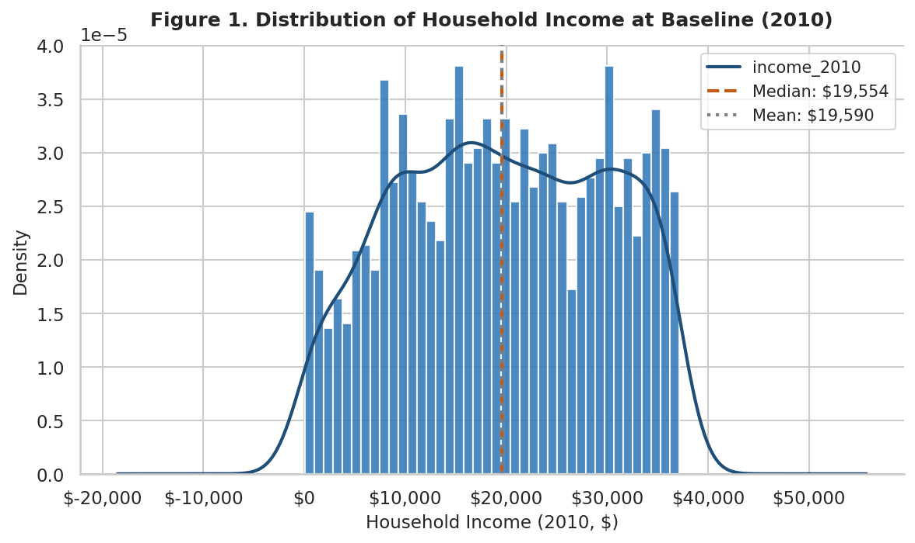
Figure 1. Distribution of household income at baseline (2010) among panel-linked low-income households (N=2,375). Income ranges from $1 to $37,190 (the 40th percentile cut). The distribution is approximately symmetric (skewness = −0.06) around a median of $19,554.
Figure 1 shows that income is distributed nearly symmetrically across the bottom 40 percent sample, with a median of $19,554 and a mean of $19,590. This similarity between mean and median confirms the absence of extreme outliers in the income variable, which is expected given the income-based sample restriction. The near-symmetric distribution is analytically important: because income variation within the sample is modest and uniform, the supervised classification models will need to rely on the other structural variables - wealth, cost burden, education, and demographics - to distinguish which households move up. This is precisely the analytic design of the project.
Figure 2: Distribution of Household Wealth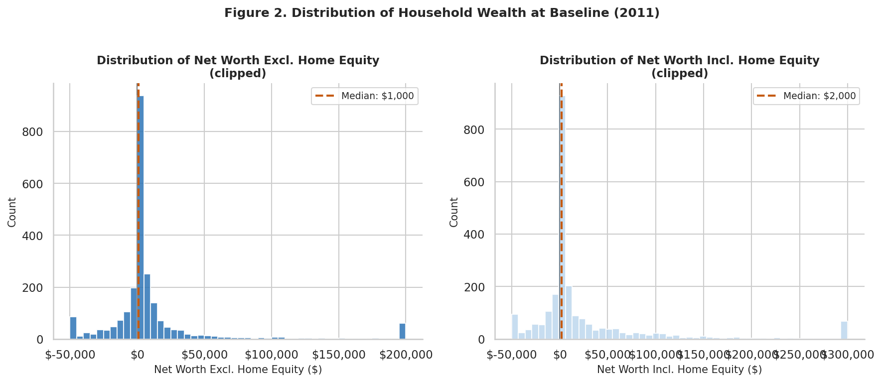
Figure 2. Distribution of household net worth at baseline (2011), shown separately excluding (left) and including (right) home equity. Both panels are clipped for visualization. Dashed lines mark group medians.
At least one in four households in this sample had zero or negative net worth at baseline, meaning a medical bill, job loss, or car repair could immediately push them into financial crisis with no cushion to absorb it. The median net worth excluding home equity is only $1,000, while the mean is $17,952, reflecting a small number of households holding dramatically more assets than the rest (skewness = 16.9). For policymakers at organizations like NLIHC, this wealth floor is the central diagnostic: two households earning identical incomes face fundamentally different risk profiles and mobility prospects depending on whether they have $0 or $50,000 in assets behind them. Wealth-building interventions, not income support alone, are implicated by this distribution.
Figure 3: Housing Cost Burden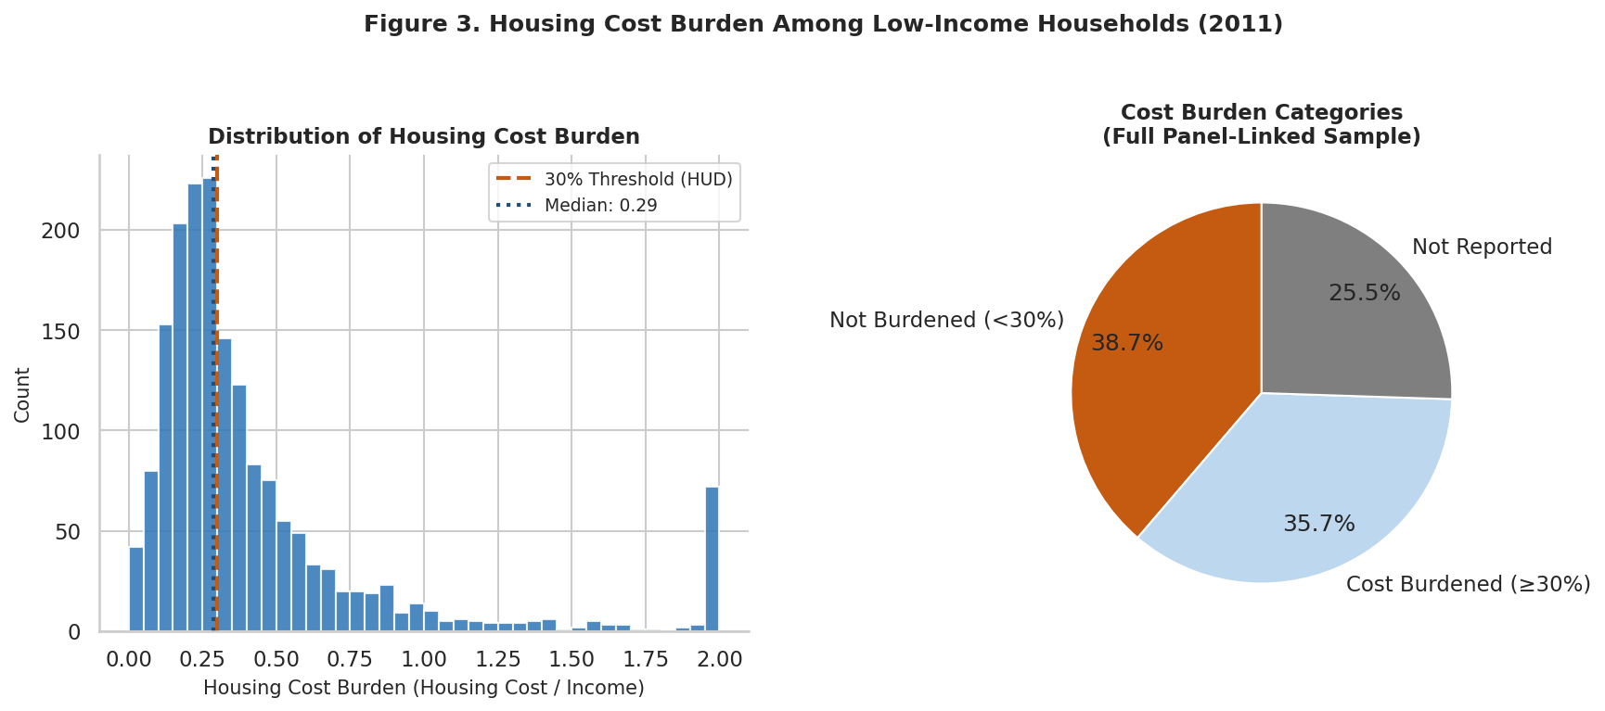
Figure 3. Left: Distribution of housing cost burden (annual housing cost / annual income) for households with reported costs (N=1,769). The vertical dashed line marks the HUD 30% cost-burden threshold. Right: Proportional breakdown of all 2,375 households by cost burden category.
Among households with available housing cost data, 48.0 percent are cost-burdened at or above the HUD 30 percent threshold (Table 2). The median burden is 0.288, meaning that the typical household with reported costs is just below the threshold - but the mean (0.432) is pulled substantially higher by households spending more than half their income on housing. For the full sample of 2,375 households (right panel), 35.7 percent are definitively cost-burdened, 38.7 percent are below the threshold, and 25.5 percent have no reported housing expenditure. This high prevalence of cost burden is directly relevant to the second hypothesis prediction and represents a clear structural constraint on savings capacity for a large share of the sample.
Figure 4: Categorical Predictor Distributions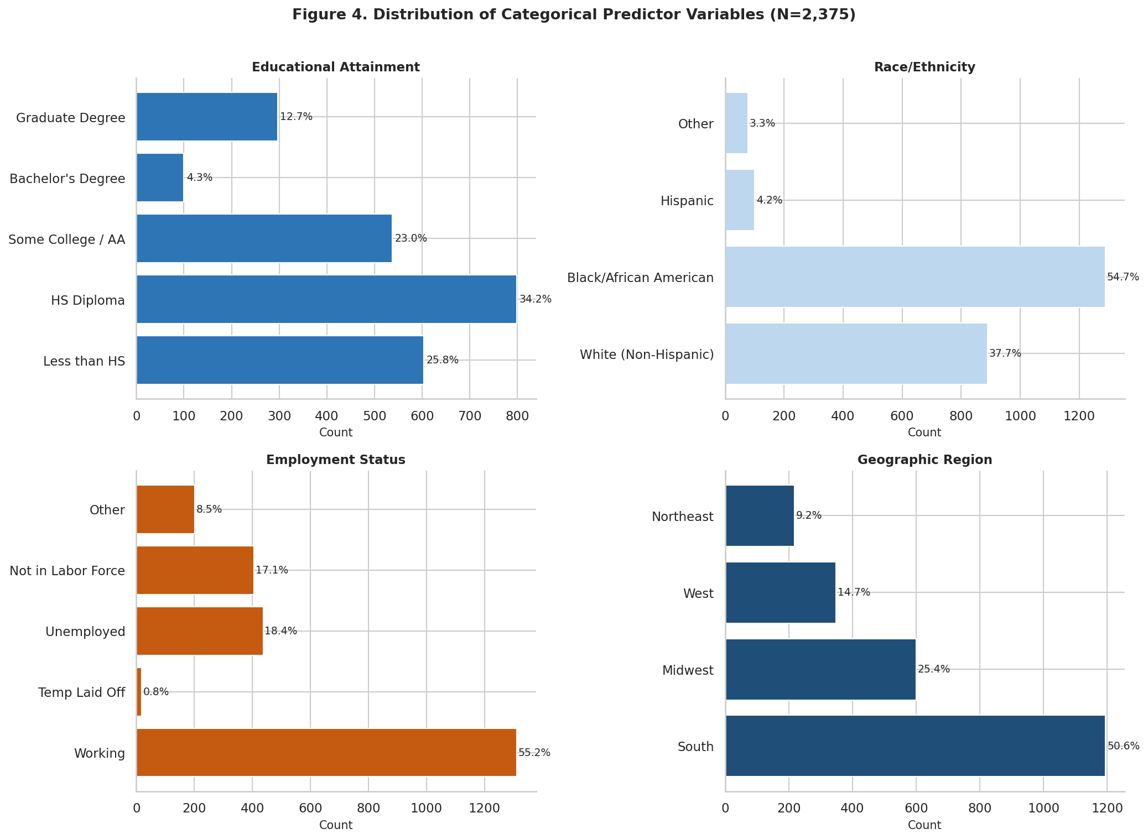
Figure 4. Frequency distributions for educational attainment (top left), race/ethnicity (top right), employment status (bottom left), and geographic region (bottom right). Percentages reflect valid observations only.
Figure 4 reveals several important structural features of the low-income sample. Educational attainment is concentrated at the lower end: 25.8 percent of heads have less than a high school diploma, and 34.2 percent have only a high school diploma, meaning 60.0 percent of the sample have no post-secondary education. Black and African American households represent 54.7 percent of the sample - a substantial overrepresentation relative to their approximately 13 percent share of the national population, consistent with documented racial disparities in income distribution (Chetty et al., 2014). Fifty-five percent of household heads are currently working, yet 18.4 percent are unemployed, underscoring that income insecurity in this sample is not simply a matter of non-employment. Geographically, 50.6 percent of households reside in the South, consistent with the concentration of poverty in Southern states.
Figure 5: Baseline Income by Race/Ethnicity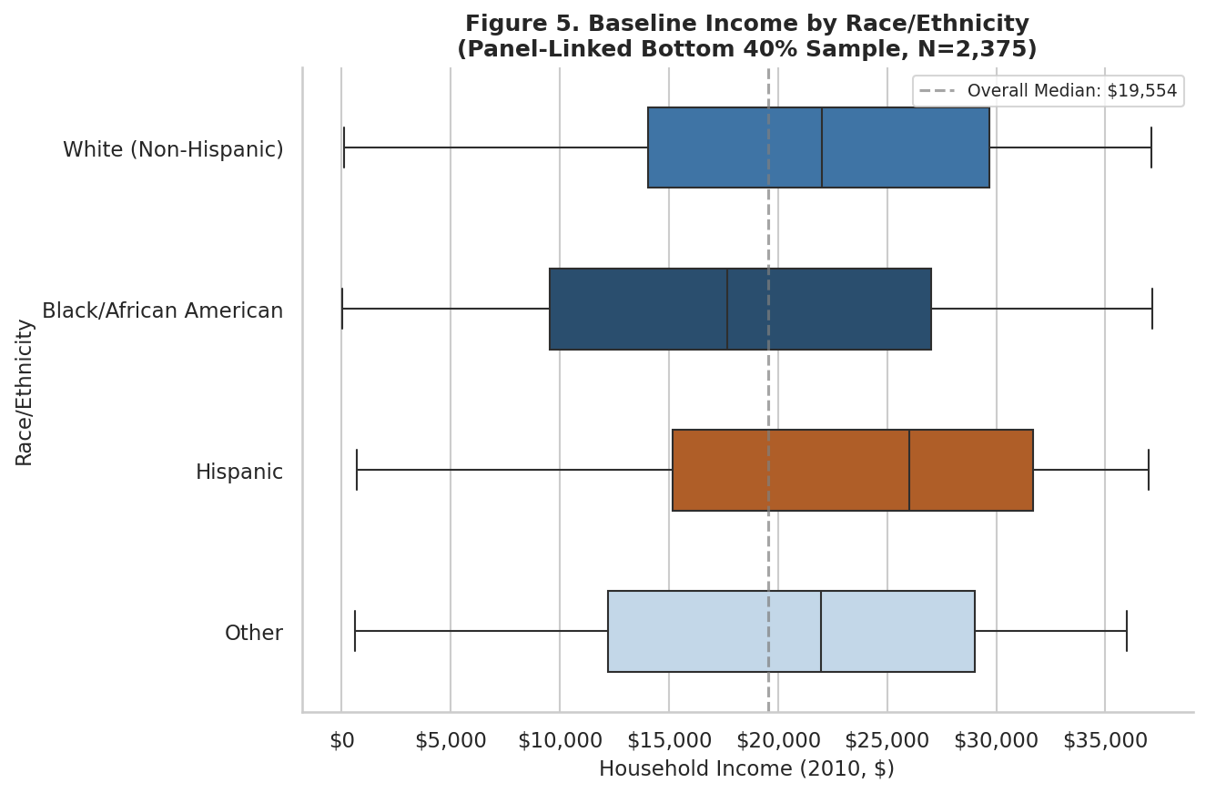
Figure 5. Box plots of baseline household income (2010) stratified by race/ethnicity. All groups are restricted to the bottom 40% of the national income distribution.
The key finding from Figure 5 is not the income similarity itself, but what that similarity means for intervention design. Even starting from identical income levels, Black households are less than half as likely as White households to achieve upward mobility a decade later (13.3% vs. 33.2%, as shown in Figure 9). That gap cannot be explained by income differences, because by sample construction, there are none. It must be driven by the structural variables that do vary by race within this income band: wealth, housing cost burden, neighborhood, and access to credit. Within Figure 5, Hispanic households show a slightly higher median income, and White (Non-Hispanic) and Black/African American households cluster near the overall median of $19,554, confirming that race-based mobility disparities in Figure 9 operate through structural channels, not income levels, and that programs targeting income alone are insufficient to close the gap.
Figure 6: Household Wealth by Educational Attainment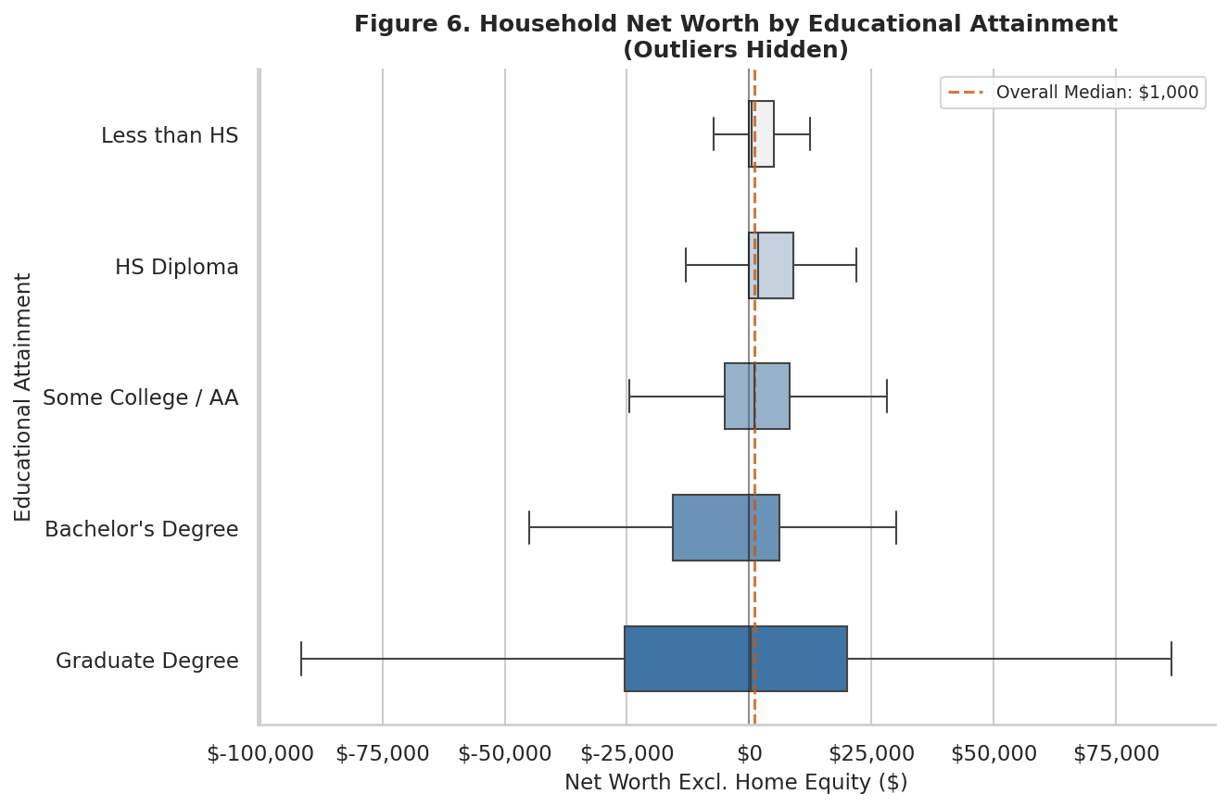
Figure 6. Box plots of household net worth (excluding home equity) stratified by educational attainment, with extreme outliers hidden. Dashed line marks the overall sample median of $1,000.
Figure 6 reveals a clear positive gradient in median net worth by educational attainment. Graduate-degree holders have substantially higher median wealth than those without a high school diploma, even within the low-income sample. This gradient is consistent with the fourth prediction: that education amplifies structural advantage in part through its association with wealth accumulation. At the same time, the wide interquartile ranges within each education category confirm that education alone does not determine wealth, lending support to the hypothesis that wealth carries independent predictive value beyond educational attainment in mobility classification.
Figure 7: Age Distribution of Household Heads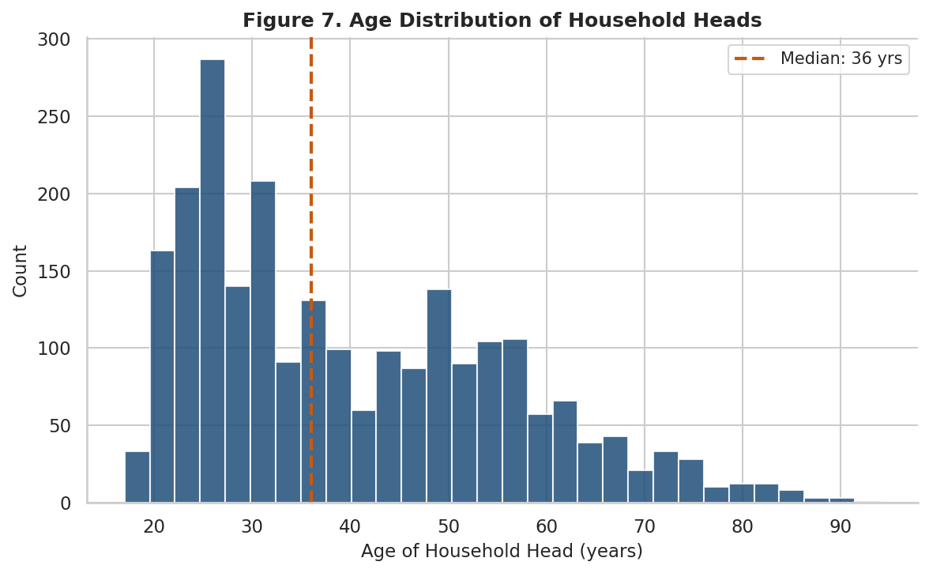
Figure 7. Distribution of the age of household heads in the panel-linked bottom 40% sample (N=2,375). Median age is 36 years.
Household heads in the analytic sample range in age from 17 to 96, with a median of 36 years and moderate positive skew (0.71). The panel-linked sample skews somewhat younger than the full 2011 PSID sample, reflecting the requirement that the household head remained trackable through the 2021 wave. Age is included as a control variable because it may interact with other structural predictors: younger heads have fewer years of wealth accumulation but potentially more time over which mobility can occur; older heads may have more stable employment but fewer years remaining in the study window.

Figure 8: Correlation Matrix of Continuous Predictors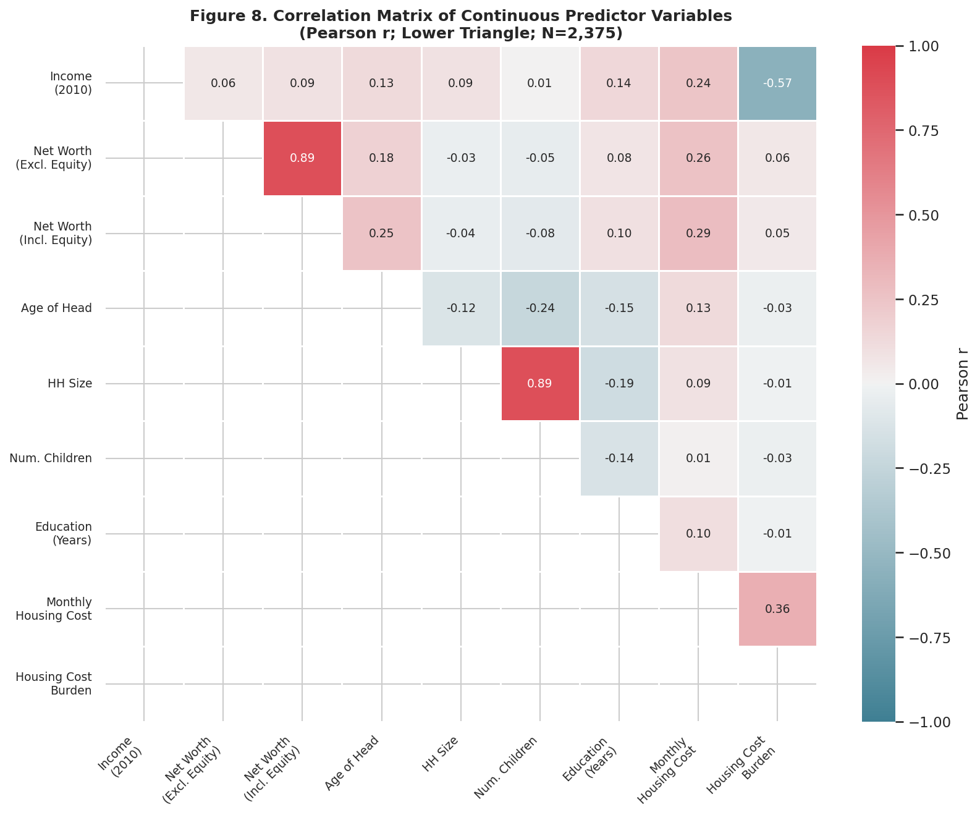
Figure 8. Pearson correlation matrix (lower triangle) for all continuous predictor variables. Blue indicates positive correlations; orange/red indicates negative correlations.
Figure 8 reveals two primary collinearity concerns. First, the two wealth measures (excluding and including home equity) are highly correlated (r = 0.89), as expected, since home equity is an additive component of total net worth; both measures should not enter the supervised models simultaneously. Second, housing cost burden is negatively correlated with income (r = −0.22), a mechanical relationship arising from the fact that burden is computed as housing cost divided by income. This collinearity was anticipated in the project proposal and will be addressed through regularization and/or by entering annual housing cost and income as separate features rather than as a pre-computed ratio. Other correlations are modest: net worth is positively correlated with income (r = 0.18) and education years (r = 0.16), and monthly housing cost correlates with income (r = 0.30) and household size (r = 0.15). These relatively low inter-predictor correlations suggest that multicollinearity will not be a severe problem for most feature pairs.
Figure 9: Observed Mobility Rate by Key Structural Predictors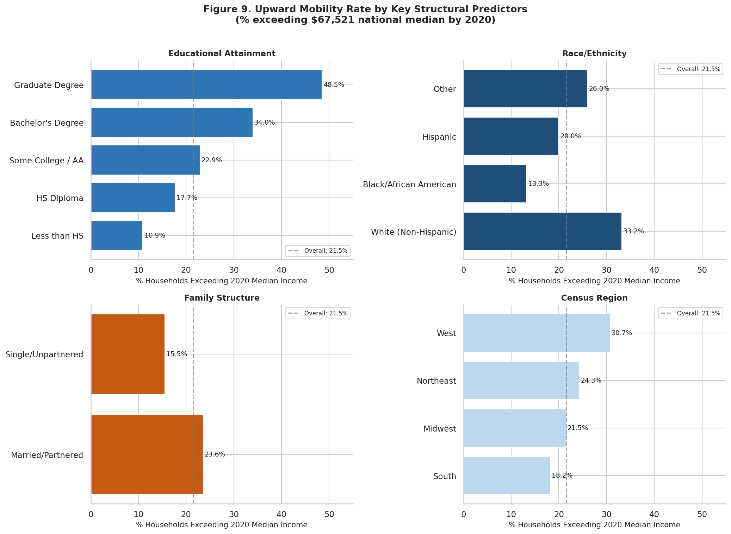
Figure 9. Observed upward mobility rate (percentage of households whose 2020 income exceeded the national median of $67,521) stratified by educational attainment (top left), race/ethnicity (top right), family structure (bottom left), and census region (bottom right). Dashed vertical line marks the overall mobility rate of 21.5%.
Figure 9 provides the most direct preview of the project’s central findings. The gradient by educational attainment is striking: only 10.9 percent of households headed by someone without a high school diploma crossed the income threshold by 2020, compared to 48.5 percent of those with a graduate degree - a more than fourfold difference. By race, White (Non-Hispanic) households achieved upward mobility at a rate of 33.2 percent, compared to 13.3 percent for Black/African American households and 20.0 percent for Hispanic households. Married or partnered households achieved mobility at 23.6 percent, compared to 15.5 percent for single or unpartnered households. Geographically, households in the Northeast and West showed higher mobility rates than those in the South and Midwest.
These raw bivariate differences are descriptive and do not account for the confounding relationships among predictors. For example, racial differences in mobility rates may partly reflect differences in baseline wealth, education, and geographic concentration rather than race itself as a causal driver. Disentangling these relationships is precisely the work of the supervised classification models in the next phase. Nonetheless, these bivariate patterns carry immediate implications for organizations like the Urban Institute and NLIHC: structural conditions at baseline are strongly associated with mobility outcomes, and the fourfold education gap and 2.5x racial gap in mobility rates suggest that interventions targeting a single lever, which is credentials alone, or income support alone, are unlikely to be sufficient. The modeling phase will provide a ranked estimate of which structural conditions, addressed in combination, offer the greatest leverage for program design.

Discussion and Next Steps
Key EDA Takeaways
The exploratory data analysis of 2,375 panel-linked PSID households reveals a sample defined by compound structural disadvantage at baseline. The most striking finding is the extreme disparity between income and wealth: while all households share similar income levels by construction of the sample restriction (median: $19,554), the median net worth is only $1,000 and at least one quarter of households have zero or negative net worth (Figure 2, Table 1). This stark contrast provides the central analytic leverage for the project: if wealth is a strong predictor of mobility within a sample where income is held relatively constant, it constitutes strong evidence for the hypothesis that structural wealth - not income alone - is the key driver of upward mobility (Chetty et al., 2014).
The housing cost burden findings are equally striking. Among households with reported costs, 48 percent are cost-burdened at or above the 30 percent HUD threshold (Figure 3), consistent with Desmond’s (2016) documentation of the housing cost crisis among low-income Americans. The observed upward mobility rates in Figure 9 reinforce all four of the project’s specific predictions at the descriptive level: educational attainment is a strong predictor (10.9% to 48.5%), racial disparities in mobility are substantial (13.3% for Black households vs. 33.2% for White), and family structure is associated with differential mobility rates. While these early patterns don't confirm that wealth and housing cost burden are stronger predictors than education, they do show meaningful variation among all variables and support moving forward with modeling. For policymakers and program designers, the preliminary implication is consequential: if wealth and housing cost burden emerge as the dominant predictors in the supervised models, it would suggest that asset-building programs and rental assistance carry more mobility impact per dollar than credential-focused interventions for this population.
Data Cleaning and Pre-Processing Plan
The analytic dataset is now substantially complete and ready for the modeling phase. The primary remaining task is handling missing data: 606 households (25.5 percent) lack housing cost data due to "Neither" tenure status, and 37 households have missing educational attainment. Multiple Imputation by Chained Equations (MICE) will be applied to these missing values strictly on the training set after an 80/20 stratified train-test split, to prevent data leakage. The housing cost burden variable’s mechanical correlation with income (r = −0.22; Figure 8) will be addressed by entering annual housing cost and household income as separate features in the models rather than as a pre-computed ratio, and regularization (L2 for logistic regression; tree depth limits for Random Forest and XGBoost) will mitigate any residual collinearity. The two highly collinear wealth measures will be resolved by retaining only net worth excluding home equity, as home equity represents a distinct asset class from the liquid and investable wealth concept central to the hypothesis. No fundamental changes to the three-phase analysis plan (K-Means clustering, followed by Logistic Regression, Random Forest, and XGBoost classification with SHAP interpretability) are required at this stage; the EDA has confirmed that all ten predictor variables are available, meaningfully distributed, and show variation relevant to the mobility outcome.

References
Chetty, R., Grusky, D., Hell, M., Hendren, N., Manduca, R., & Narang, J. (2017). The fading American dream: Trends in absolute income mobility since 1940. Science, 356(6336), 398 - 406.
Chetty, R., Hendren, N., Kline, P., & Saez, E. (2014). Where is the land of opportunity? The geography of intergenerational mobility in the United States. Quarterly Journal of Economics, 129(4), 1553 - 1623.
Desmond, M. (2016). Evicted: Poverty and profit in the American city. Crown Publishers.
Putnam, R. D. (2015). Our kids: The American dream in crisis. Simon & Schuster.
University of Michigan Institute for Social Research. (2023). Panel Study of Income Dynamics [public use dataset]. Survey Research Center. https://psidonline.isr.umich.edu
Appendix A: Data Dictionary / Codebook
The following table describes all variables used in the analysis, including PSID source variable codes, operational definitions, measurement levels, and coding decisions.

Variable Name | PSID Code(s) | Definition | Type | Coding Notes
Household Income (2010) | ER52343 | Total family income for calendar year 2010, reported in 2011 wave | Continuous ($) | Values of 9,999,999 recoded as missing. Restricted to ≤40th percentile ($37,190). N=2,375.
Net Worth (excl. equity) | ER52392 | Imputed net worth excluding home equity (Wealth1), 2011 PSID wealth supplement | Continuous ($) | PSID imputed value. Values of ±9,999,999 recoded as missing. Highly right-skewed (skew=16.9). Primary wealth predictor.
Net Worth (incl. equity) | ER52394 | Imputed net worth including home equity (Wealth2), 2011 PSID wealth supplement | Continuous ($) | PSID imputed value. Collinear with excl. equity (r=0.89). Will be dropped from models; retained in EDA for reference.
Age of Head | ER47317 | Age in years of household head at time of 2011 interview | Continuous (years) | Values ≥98 recoded as missing. Range: 17 - 96. Median: 36.
Household Size | ER47316 | Total number of persons in the family unit at 2011 interview | Continuous (count) | Includes head, spouse/partner, children, and other FU members.
Number of Children | ER47320 | Number of children in family unit at 2011 interview | Continuous (count) | Includes biological, adoptive, and step-children under 18 in FU.
Educational Attainment | ER52405 | Highest grade of schooling completed by household head (years) | Ordinal (5 cats.) | Recoded: ≤11=Less than HS; 12=HS Diploma; 13 - 14=Some College/AA; 15=Bachelor’s; 16 - 17=Graduate.
Employment Status | ER47448 | Employment status of household head (first mention) | Nominal (5 cats.) | Original 8 codes collapsed: 1=Working; 2=Temp Laid Off; 3=Unemployed; 4 - 5=Not in LF; 6 - 8=Other.
Family Structure | ER52407 | Marital/partnership status of household head | Binary (nominal) | Codes 1 - 3 (married/partnered) = Married/Partnered; codes 4 - 7 = Single/Unpartnered.
Race/Ethnicity | ER51904, ER51903 | Race and Hispanic origin of household head | Nominal (4 cats.) | Hispanic origin (ER51903=1) takes precedence. Categories: White (Non-Hispanic), Black/AA, Hispanic, Other.
Geographic Region | ER52398 | PSID Census region of household residence at 2011 interview | Nominal (4 cats.) | Codes: 1=Northeast; 2=Midwest; 3=South; 4 - 5=West (Alaska/Hawaii grouped with West).
Housing Tenure | ER47329 | Whether household owns, rents, or has other arrangement | Nominal (3 cats.) | Codes: 1=Owner; 5=Renter; 8=Neither. Neither group lacks housing cost data.
Monthly Housing Cost | ER47350, ER47371, ER47387 | Monthly housing expenditure (mortgage for owners; rent for renters) | Continuous ($) | Owner: sum of primary and secondary mortgage payments. Renter: monthly rent (period code 5). Missing for Neither tenure (N=606).
Housing Cost Burden | Derived | Annual housing cost divided by annual household income | Continuous (ratio) | = (monthly cost × 12) / income_2010. Clipped at 2.0. Missing for 606 households without housing cost data.
Above Median (Target) | ER81775 (2021) | Binary: did household income in 2020 exceed national median ($67,521)? | Binary (0/1) | 2021 wave income (ER81775) covers calendar year 2020. Linked via Cross-Year Individual file (IND2023ER). Mobility rate: 21.5%.
Panel Linkage IDs | ER34101, ER34901 | 2011 and 2021 family interview numbers from Cross-Year Individual file | Identifier | Used to merge FAM2011ER to FAM2021ER. Sequence number ER34102=1 identifies household heads in 2011.
Note: All baseline variables are drawn from the 2011 PSID Family File (FAM2011ER) unless otherwise noted. Panel linkage uses the 2023 Cross-Year Individual File (IND2023ER). Target variable income is from the 2021 Family File (FAM2021ER).

